RESERVE ANALYSIS REPORT

**Lookout Ridge HOA**, Herriman UT, 84096

Study with site Inspection

Fiscal year ending 2014



Prepared by:

Raymond Sariego, Board Member, on behalf of Lookout Ridge Board of Directors

Date: 6/01/2014

Table of Contents

Executive Summary 3

Utah Law 3

Community Description 3

Facilities 3

Conclusions 3

Percent Funded 5

30 Year Projections 6

Component Summary 8

Annual Expenses by Component 9

Component Details 12

Glossary of Terms 16

Executive Summary

# Executive Summary

## Utah Law

Utah Title 57, Chapter 8a, Section 211requires HOAs to conduct a Reserve Analysis to determine the need to accumulate money to cover maintenance and repair costs and to determine the appropriate amount of any reserve fund.

## Community Description

Lookout Ridge (LOR) is an HOA consisting of 100 single family homes constructed by multiple builders (both custom and regular) which was established in 2007. As of the date of this report, there are 56 homes occupied, 14 under construction, three plans approved for construction, and 27 lots with no current plans for construction on file.

## Facilities

There are no community facilities and only limited public common areas consisting of two entrances/exits with landscaping, irrigation systems, lighting, fencing, security cameras, signage, and large bronze elk statues (one at each entrance).

## Conclusions

The community has approximately $22,000 in savings and approximately $160,000 in maintainable assets at the time of this report. Given the current level of savings and a net income of approximately $5,000 dollars annually, the community is in an excellent position to begin funding a $20,000 reserve fund without the need for supplemental assessments or increases in dues. Given the current asset condition and maintenance needs, a $20,000 reserve fund will be sufficient for Lookout Ridge, pending any changes to the asset base. This analysis will be reviewed as required every three years, or sooner as needed. The Reserve Fund is expected to be fully funded by 12/31/2017.

**Reserve Fund Balance December 31, 2013** (Prior to Creation of Reserve Fund).

|  |  |
| --- | --- |
| Fully Funded Reserve Balance (As determined by the study) | $ 20,000 |
| Reserve Balance (12/31/2013) | $ 0.00 |
| Under Funded (Deficiency in reserve funding) | $ 20,000 |
| Deficiency in Reserve Funding Per Lot | $ 200 |
| Percent Funded (Prior to creation of Reserve Fund) | **0.00%** |

**Reserve Fund Balance** (anticipated) December 31, 2014.

|  |  |
| --- | --- |
| Fully Funded Reserve Balance | $20,000 |
| Projected Balance (Funded from savings) | $ 5,000 |
| Under Funded (Deficiency in reserve funding) | $15,000 |
| Deficiency in Reserve Funding Per Lot | $ 150 |
| Percent Funded (December 31, 2014) | **25%** |

**Reserve Contribution Schedule**

|  |  |
| --- | --- |
| 2014 Budgeted Reserve Contribution (From existing savings) | $5,000 |
| 2015 Budgeted Reserve Contribution | $5,600 |
| 2016 Budgeted Reserve Contribution | $5,618 |
| 2017 Budgeted Reserve Contribution (Fully Funded by 12/31/17) | $5,637 |

## 

Percent Funded

# Percent Funded (12/31/2014)

Percent Funded is probably the most important number in a reserve study.

Your current percent funded is:

|  |  |  |  |
| --- | --- | --- | --- |
| Year End Balance | $5000.00 | = | **25.00%** |
| Fully Funded Balance | $20,000 |

|  |  |  |
| --- | --- | --- |
| Above 70% = Well Funded | Between 30% and 70% = Fairly Funded | Below 30% = Poorly Funded |

The higher your percent funded, the lower the risk of special assessments and deferred maintenance. As maintenance occurs, there will be a drop in percentage funded amount; however, this will be offset by the extended life of the refreshed asset.

30 Year Projections

# 30 Year Projections

Reserve expenses will vary from year to year. A reserve study predicts these expenses and offsets them by creating a uniform funding plan that increases slightly over time to keep up with inflation. This reserve fund balance is adjusted up at an annual rate of 3% to allow for historical average inflation, and will show drops as required maintenance or replacement is scheduled. The following chart displays projections for: Proposed balance with inflation, Anticipated actual balance after maintenance, and Maintenance needs.

Component Summary

# Component Summary

This table summarizes assets, their useful life, and their present value replacement cost in addition to items that require regularly scheduled maintenance. It does not include maintenance contracts such as those for landscaping care or security systems.

|  |  |  |  |  |  |  |  |  |
| --- | --- | --- | --- | --- | --- | --- | --- | --- |
| **Category**  Component | Quantity | Unit of  Measure | Useful  Life | Install  Year | Remaining  Life | Unit  Cost | Total Cost | Annual  Contribution |
| **Statues** |  |  |  |  |  |  |  |  |
| Elk | 2 | Each | 100 | 2007 | 93 | $40,000 | $80,000 | $800 |
| **Signage** |  |  |  |  |  |  |  |  |
| East Granite Signs | 2 | Each | 100 | 2007 | 93 | $5000 | $20,000 | $200 |
| East Wooden Poles | 12 | Each | 30 | 2007 | 23 | $167 | $2,000 | $67 |
|  |  |  |  |  |  |  |  |  |
| **Fencing** |  |  |  |  |  |  |  |  |
| East Entrance | 258 | LF | 25 | 2007 | 18 | $34.73 | $8,960 | $359 |
|  |  |  |  |  |  |  |  |  |
| **Lighting** |  |  |  |  |  |  |  |  |
| East Entrance | 1 | Each | 25 | 2007 | 18 | $5,275 | $5,275 | $211 |
|  |  |  |  |  |  |  |  |  |
| **Irrigation/Landscape** |  |  |  |  |  |  |  |  |
| Sprinkler System | 2 | Each | 30 | 2007 | 23 | $15,738 | $31,475 | $1,049 |
| Backflow Valves | 2 | Each | 20 | 2007 | 13 | $400 | $800 | $40 |
| Controllers | 2 | Each | 12 | 2007 | 5 | $200 | $400 | $34 |
|  |  |  |  |  |  |  |  |  |
| **Painting/Sealing** |  |  |  |  |  |  |  |  |
| Entry Signage Poles | 4 | Each | 4 | 2014 | 4 | $112 | $450 | $112 |
| Mailboxes | 2 | Each | 4 | 2007 | -2 | $225 | $450 | $112 |
| Granite Sign | 1 | Each | 8 | 2007 | 1 | $1,200 | $1,200 | $150 |
| **Security** |  |  |  |  |  |  |  |  |
| License Cameras | 2 | Each | 10 | 2013 | 9 | $650 | $1,300 | $130 |
| Regular Cameras | 7 | Each | 10 | 2007 | 3 | $300 | $2,100 | $210 |
| Security Lights | 2 | Each | 10 | 2013 | 10 | $1,100 | $2,200 | $220 |
| Computer/DVR | 2 | Each | 10 | 2007 | 3 | $1,000 | $2,000 | $200 |
| Modem* | 1 | Each | N/A | 2007 | 0 | 0 | 0 | 0 |
| Router* | 1 | Each | N/A | 2007 | 0 | 0 | 0 | 0 |
| *Comcast Rental |  |  |  |  |  |  |  |  |
| **TOTAL (Excludes Elk Statue & Granite Signs)** | | | | |  |  |  | **$2,894** |

Annual Expenses by Component

# Annual Expenses by Component

Detailed 30 year maintenance/replacement data, by year, supporting the chart on page 6. Replacement Cost is based on future value at the time of replacement using 3% inflation rates.

|  |  |  |  |  |  |  |  |  |  |  |
| --- | --- | --- | --- | --- | --- | --- | --- | --- | --- | --- |
| **Category**  Component | 2014 | 2015 | 2016 | 2017 | 2018 | 2019 | 2020 | 2021 | 2022 | 2023 |
| **Statues** |  |  |  |  |  |  |  |  |  |  |
| Elk | 0 | 0 | 0 | 0 | 0 | 0 | 0 | 0 | 0 | 0 |
| **Signage** |  |  |  |  |  |  |  |  |  |  |
| East Granite Sign | 0 | 0 | 0 | 0 | 0 | 0 | 0 | 0 | 0 | 0 |
| East Wooden Poles | 0 | 0 | 0 | 0 | 0 | 0 | 0 | 0 | 0 | 0 |
|  |  |  |  |  |  |  |  |  |  |  |
| **Fencing** |  |  |  |  |  |  |  |  |  |  |
| East Entrance | 0 | 0 | 0 | 0 | 0 | 0 | 0 | 0 | 0 | 0 |
|  |  |  |  |  |  |  |  |  |  |  |
| **Lighting** |  |  |  |  |  |  |  |  |  |  |
| East Entrance | 0 | 0 | 0 | 0 | 0 | 0 | 0 | 0 | 0 | 0 |
|  |  |  |  |  |  |  |  |  |  |  |
| **Irrigation/Landscape** |  |  |  |  |  |  |  |  |  |  |
| Sprinkler System | 0 | 0 | 0 | 0 | 0 | 0 | 0 | 0 | 0 | 0 |
| Backflow Valves | 0 | 0 | 0 | 0 | 0 | 0 | 0 | 0 | 0 | 0 |
| Controllers | 0 | 0 | 0 | 0 | 0 | $556 | 0 | 0 | 0 | 0 |
|  |  |  |  |  |  |  |  |  |  |  |
| **Painting/Sealing** |  |  |  |  |  |  |  |  |  |  |
| Entry Signage Poles | $450 | 0 | 0 | 0 | $502 | 0 | 0 | 0 | $561 | 0 |
| Mailboxes | $450 | 0 | 0 | 0 | $502 | 0 | 0 | 0 | $561 | 0 |
| Granite Sign | 0 | $1,235 | 0 | 0 | 0 | 0 | 0 | 0 | 0 | $1,556 |
| **Security** |  |  |  |  |  |  |  |  |  |  |
| License Cameras | $1,300 | 0 | 0 | 0 | 0 | 0 | 0 | 0 | 0 | 0 |
| Regular Cameras | 0 | 0 | 0 | $3281 | 0 | 0 | 0 | 0 | 0 | 0 |
| Security Lights | 0 | 0 | 0 | 0 | 0 | 0 | 0 | $0 | 0 | $2,945 |
| Computer | 0 | 0 | 0 | $2676 | 0 | 0 | 0 | 0 | 0 | 0 |
| Modem (Rental) | 0 | 0 | 0 | 0 | 0 | 0 | 0 | 0 | 0 | 0 |
| Router (Rental) | 0 | 0 | 0 | 0 | 0 | 0 | 0 | 0 | 0 | 0 |
|  |  |  |  |  |  |  |  |  |  |  |
|  | 2014 | 2015 | 2016 | 2017 | 2018 | 2019 | 2020 | 2021 | 2022 | 2023 |
| **ANNUAL TOTALS** | **$2,200** | **$1,235** | **$0.00** | **$5,957** | **$1,004** | **$556** | **$0.00** | **$0.00** | **$1,122** | **$4,501** |

Annual Expenses by Component (continued, years 11-20)

|  |  |  |  |  |  |  |  |  |  |  |
| --- | --- | --- | --- | --- | --- | --- | --- | --- | --- | --- |
| **Category**  Component | 2024 | 2025 | 2026 | 2027 | 2028 | 2029 | 2030 | 2031 | 2032 | 2033 |
| **Statues** |  |  |  |  |  |  |  |  |  |  |
| Elk | 0 | 0 | 0 | 0 | 0 | 0 | 0 | 0 | 0 | 0 |
| **Signage** |  |  |  |  |  |  |  |  |  |  |
| East Granite Sign | 0 | 0 | 0 | 0 | 0 | 0 | 0 | 0 | 0 | 0 |
| East Wooden Poles | 0 | 0 | 0 | 0 | 0 | 0 | 0 | 0 | 0 | 0 |
|  |  |  |  |  |  |  |  |  |  |  |
| **Fencing** |  |  |  |  |  |  |  |  |  |  |
| East Entrance | 0 | 0 | 0 | 0 | 0 | 0 | 0 | 0 | $18,723 | 0 |
|  |  |  |  |  |  |  |  |  |  |  |
| **Lighting** |  |  |  |  |  |  |  |  |  |  |
| East Entrance | 0 | 0 | 0 | 0 | 0 | 0 | 0 | 0 | $11,008 | 0 |
|  |  |  |  |  |  |  |  |  |  |  |
| **Irrigation/Landscape** |  |  |  |  |  |  |  |  |  |  |
| Sprinkler System | 0 | 0 | 0 | 0 | 0 | 0 | 0 | 0 | 0 | 0 |
| Backflow Valves | 0 | 0 | 0 | $1,418 | 0 | 0 | 0 | 0 | 0 | 0 |
| Controllers | 0 | 0 | 0 | 0 | 0 | 0 | 0 | $779 | 0 | 0 |
|  |  |  |  |  |  |  |  |  |  |  |
| **Painting/Sealing** |  |  |  |  |  |  |  |  |  |  |
| Entry Signage Poles | 0 | 0 | $627 | 0 | 0 | 0 | $702 | 0 | 0 | 0 |
| Mailboxes | 0 | 0 | $627 | 0 | 0 | 0 | $702 | 0 | 0 | 0 |
| Granite Sign | 0 | 0 | 0 | 0 | 0 | 0 | 0 | $1,962 | 0 | 0 |
| **Security** |  |  |  |  |  |  |  |  |  |  |
| License Cameras | $1,736 | 0 | 0 | 0 | 0 | 0 | 0 | 0 | 0 | 0 |
| Regular Cameras | 0 | 0 | 0 | $4,398 | 0 |  | 0 | 0 | 0 | 0 |
| Security Lights | 0 | 0 | 0 | 0 | 0 | 0 | 0 | $0 | 0 | $3,946 |
| Computer | 0 | 0 | 0 | $3,585 | 0 | 0 | 0 | 0 | 0 | 0 |
| Modem (Rental) | 0 | 0 | 0 | 0 | 0 | 0 | 0 | 0 | 0 | 0 |
| Router (Rental) | 0 | 0 | 0 | 0 | 0 | 0 | 0 | 0 | 0 | 0 |
|  |  |  |  |  |  |  |  |  |  |  |
|  | 2024 | 2025 | 2026 | 2027 | 2028 | 2029 | 2030 | 2031 | 2032 | 2033 |
| **ANNUAL TOTALS** | **$1,736** | **$0.00** | **$1,254** | **$9,401** | **$0.00** | **$0.00** | **$1,404** | **$2,741** | **$29,731** | **$3,946** |

Annual Expenses by Component (continued, years 21-30)

|  |  |  |  |  |  |  |  |  |  |  |
| --- | --- | --- | --- | --- | --- | --- | --- | --- | --- | --- |
| **Category**  Component | 2034 | 2035 | 2036 | 2037 | 2038 | 2039 | 2040 | 2041 | 2042 | 2043 |
| **Statues** |  |  |  |  |  |  |  |  |  |  |
| Elk | 0 | 0 | 0 | 0 | 0 | 0 | 0 | 0 | 0 | 0 |
| **Signage** |  |  |  |  |  |  |  |  |  |  |
| East Granite Sign | 0 | 0 | 0 | 0 | 0 | 0 | 0 | 0 | 0 | 0 |
| East Wooden Poles | 0 | 0 | 0 | $4,807 | 0 | 0 | 0 | 0 | 0 | 0 |
|  |  |  |  |  |  |  |  |  |  |  |
| **Fencing** |  |  |  |  |  |  |  |  |  |  |
| East Entrance | 0 | 0 | 0 | 0 | 0 | 0 | 0 | 0 | 0 | 0 |
|  |  |  |  |  |  |  |  |  |  |  |
| **Lighting** |  |  |  |  |  |  |  |  |  |  |
| East Entrance | 0 | 0 | 0 | 0 | 0 | 0 | 0 | 0 | 0 | 0 |
|  |  |  |  |  |  |  |  |  |  |  |
| **Irrigation/Landscape** |  |  |  |  |  |  |  |  |  |  |
| Sprinkler System | 0 | 0 | 0 | 0 | 0 | 0 | 0 | 0 | 0 | 0 |
| Backflow Valves | 0 | 0 | 0 | 0 | 0 | 0 | 0 | 0 | 0 | 0 |
| Controllers | 0 | 0 | 0 | 0 | 0 | 0 | 0 | 0 | 0 | $1,096 |
|  |  |  |  |  |  |  |  |  |  |  |
| **Painting/Sealing** |  |  |  |  |  |  |  |  |  |  |
| Entry Signage Poles | $786 | 0 | 0 | 0 | $880 | 0 | 0 | 0 | $986 | 0 |
| Mailboxes | $786 | 0 | 0 | 0 | $880 | 0 | 0 | 0 | $986 | 0 |
| Granite Sign | 0 | 0 | 0 | 0 | 0 | $2,477 | 0 | 0 | 0 | 0 |
| **Security** |  |  |  |  |  |  |  |  |  |  |
| License Cameras | $2,322 | 0 | 0 | 0 | 0 | 0 | 0 | 0 | 0 | 0 |
| Regular Cameras | 0 | 0 | 0 | $5,899 | 0 |  | 0 | 0 | 0 | 0 |
| Security Lights | 0 | 0 | 0 | 0 | 0 | 0 | 0 | 0 | 0 | $5,292 |
| Computer | 0 | 0 | 0 | $4,807 | 0 | 0 | 0 | 0 | 0 | 0 |
| Modem (Rental) | 0 | 0 | 0 | 0 | 0 | 0 | 0 | 0 | 0 | 0 |
| Router (Rental) | 0 | 0 | 0 | 0 | 0 | 0 | 0 | 0 | 0 | 0 |
|  |  |  |  |  |  |  |  |  |  |  |
|  | 2034 | 2035 | 2036 | 2037 | 2038 | 2039 | 2040 | 2041 | 2042 | 2043 |
| **ANNUAL TOTALS** | **$3,894** | **$0.00** | **$0.00** | **$15,513** | **$1,760** | **$2,477** | **$0.00** | **$0.00** | **$1,972** | **$6,388** |

Component Details

# Component Details

|  |  |  |  |  |  |
| --- | --- | --- | --- | --- | --- |
| **Statues** | | **Elk** | | | |
| Component Quantity | 2 | | Cost Source | 1 |
| Unit of Measure | Each | | Estimated Current Unit Cost | $40,000 |
| Normal Useful Life (Years) | 100 | | Estimated Total Current Cost | $80,000 |
| Estimated Remaining Useful Life (Years) | 94 | | Estimated Total Future Cost | $1,536,883 |
| Install Year | 2007 | |  |  |
| Estimated Replacement Year | 2107 | |  |  |

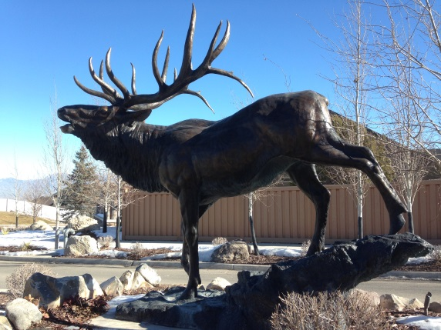

|  |  |  |  |  |  |
| --- | --- | --- | --- | --- | --- |
| **Signage** | | **East Granite Signs** | | | |
| Component Quantity | 2 | | Cost Source | 1 |
| Unit of Measure | Each | | Estimated Current Unit Cost | $5,000 |
| Normal Useful Life (Years) | 100 | | Estimated Total Current Cost | $10,000 |
| Estimated Remaining Useful Life (Years) | 94 | | Estimated Total Future Cost | $24,225 |
| Install Year | 2007 | |  |  |
| Estimated Replacement Year | 2107 | |  |  |

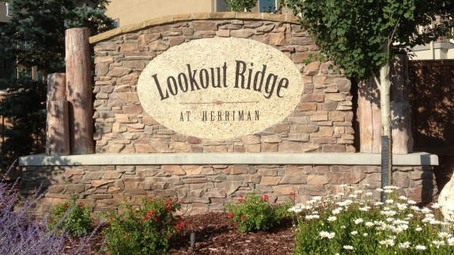

|  |  |  |  |  |  |
| --- | --- | --- | --- | --- | --- |
| **Signage** | | **East Wooden Poles** | | | |
| Component Quantity | 12 | | Cost Source | 1 |
| Unit of Measure | Each | | Estimated Current Unit Cost | $167 |
| Normal Useful Life (Years) | 30 | | Estimated Total Current Cost | $2,000 |
| Estimated Remaining Useful Life (Years) | 24 | | Estimated Total Future Cost | $4,807 |
| Install Year | 2007 | |  |  |
| Estimated Replacement Year | 2037 | |  |  |

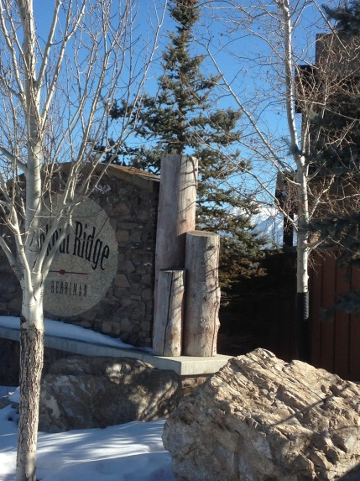

|  |  |  |  |  |  |
| --- | --- | --- | --- | --- | --- |
| **Fencing** | | **East Entrance** | | | |
| Component Quantity (Approx.) | 258 | | Cost Source | 1 |
| Unit of Measure | LF | | Estimated Current Unit Cost | $34.73 |
| Normal Useful Life (Years) | 25 | | Estimated Total Current Cost | $8,960 |
| Estimated Remaining Useful Life (Years) | 19 | | Estimated Total Future Cost | $18,723 |
| Install Year | 2007 | |  |  |
| Estimated Replacement Year | 2032 | |  |  |

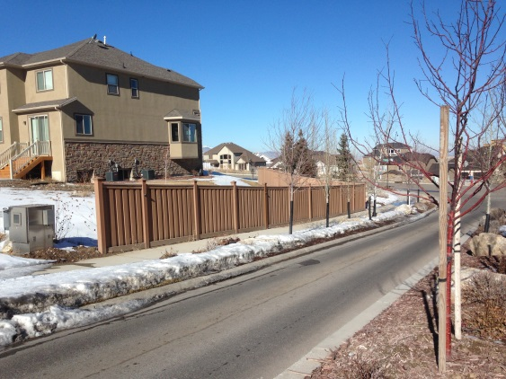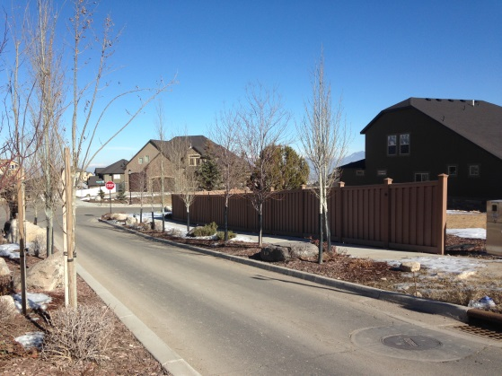

|  |  |  |  |  |  |
| --- | --- | --- | --- | --- | --- |
| **Lighting** | | **East Entrance** | | | |
| Component Quantity | 1 | | Cost Source | 1 |
| Unit of Measure | Each | | Estimated Current Unit Cost | $5,275 |
| Normal Useful Life (Years) | 25 | | Estimated Total Current Cost | $5,275 |
| Estimated Remaining Useful Life (Years) | 19 | | Estimated Total Future Cost | $11,008 |
| Install Year | 2007 | |  |  |
| Estimated Replacement Year | 2032 | |  |  |

|  |  |  |  |  |  |
| --- | --- | --- | --- | --- | --- |
| **Irrigation/Landscape** | | **Sprinkler System** | | | |
| Component Quantity | 2 | | Cost Source | 1 |
| Unit of Measure | Each | | Estimated Current Unit Cost | $15,738 |
| Normal Useful Life (Years) | 30 | | Estimated Total Current Cost | $31,475 |
| Estimated Remaining Useful Life (Years) | 24 | | Estimated Total Future Cost | Maintain instead of replace. |
| Install Year | 2007 | |  |  |
| Estimated Replacement Year | 2037 | |  |  |

|  |  |  |  |  |  |
| --- | --- | --- | --- | --- | --- |
| **Irrigation/Landscape** | | **Backflow Valves** | | | |
| Component Quantity | 2 | | Cost Source | 2 |
| Unit of Measure | Each | | Estimated Current Unit Cost | $400 |
| Normal Useful Life (Years) | 20 | | Estimated Total Current Cost | $800 |
| Estimated Remaining Useful Life (Years) | 14 | | Estimated Total Future Cost | $1,418 |
| Install Year | 2007 | |  |  |
| Estimated Replacement Year | 2027 | |  |  |

|  |  |  |  |  |  |
| --- | --- | --- | --- | --- | --- |
| **Irrigation/Landscape** | | **Controllers** | | | |
| Component Quantity | 2 | | Cost Source | 1 |
| Unit of Measure | Each | | Estimated Current Unit Cost | $200 |
| Normal Useful Life (Years) | 12 | | Estimated Total Current Cost | $400 |
| Estimated Remaining Useful Life (Years) | 6 | | Estimated Total Future Cost | $556 |
| Install Year | 2007 | |  |  |
| Estimated Replacement Year | 2019 | |  |  |

|  |  |  |  |  |  |
| --- | --- | --- | --- | --- | --- |
| **Security** | | **License Plate Cameras** | | | |
| Component Quantity | 2 | | Cost Source | 3 |
| Unit of Measure | Each | | Estimated Current Unit Cost | $650 |
| Normal Useful Life (Years) | 10 | | Estimated Total Current Cost | $1,300 |
| Estimated Remaining Useful Life (Years) | 10 | | Estimated Total Future Cost | $1,736 |
| Install Year | 2013-2014 | |  |  |
| Estimated Replacement Year | 2024 | |  |  |

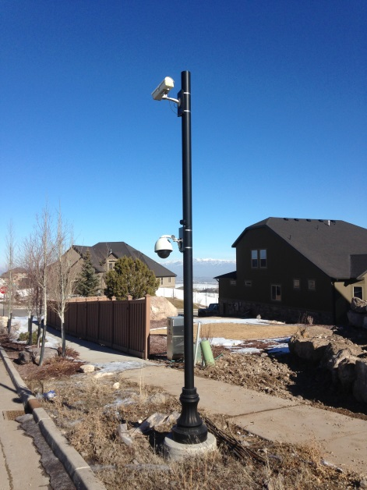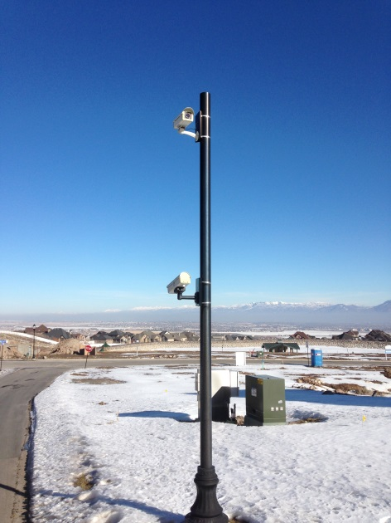

|  |  |  |  |  |  |
| --- | --- | --- | --- | --- | --- |
| **Security** | | **Regular Cameras** | | | |
| Component Quantity | 7 | | Cost Source | 3 |
| Unit of Measure | Each | | Estimated Current Unit Cost | $350 |
| Normal Useful Life (Years) | 10 | | Estimated Total Current Cost | $2,450 |
| Estimated Remaining Useful Life (Years) | 4 | | Estimated Total Future Cost | $3,281 |
| Install Year | 2007 | |  |  |
| Estimated Replacement Year | 2017 | |  |  |

|  |  |  |  |  |  |
| --- | --- | --- | --- | --- | --- |
| **Security** | | **Security Lights in Upper Cul-De-Sacs** | | | |
| Component Quantity | 2 | | Cost Source | 3 |
| Unit of Measure | Each | | Estimated Current Unit Cost | $1,100 |
| Normal Useful Life (Years) | 10 | | Estimated Total Current Cost | $2,200 |
| Estimated Remaining Useful Life (Years) | 10 | | Estimated Total Future Cost | $2,945 |
| Install Year | 2013 | |  |  |
| Estimated Replacement Year | 2023 | |  |  |

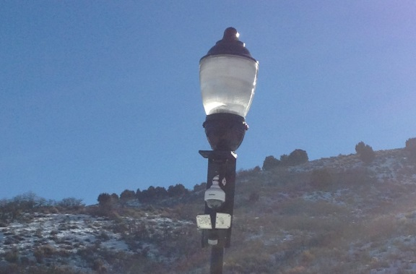

|  |  |  |  |  |  |
| --- | --- | --- | --- | --- | --- |
| **Security** | | **Computer** | | | |
| Component Quantity | 2 | | Cost Source | 1 |
| Unit of Measure | Each | | Estimated Current Unit Cost | $1,000 |
| Normal Useful Life (Years) | 10 | | Estimated Total Current Cost | $2,000 |
| Estimated Remaining Useful Life (Years) | 3 | | Estimated Total Future Cost | $2,676 |
| Install Year | 2007 | |  |  |
| Estimated Replacement Year | 2017 | |  |  |

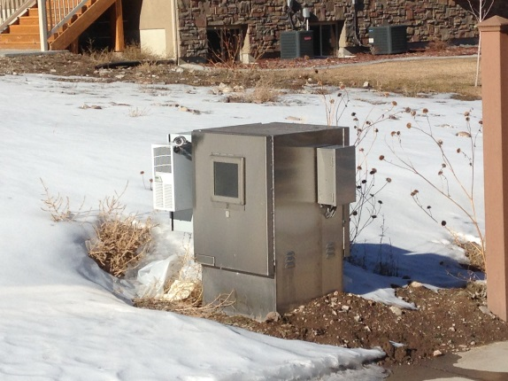

|  |  |  |  |  |  |
| --- | --- | --- | --- | --- | --- |
| **Security** | | **Modem, Router** | | | |
| Component Quantity | 1 | | Cost Source | 1 |
| Unit of Measure | Each | | Estimated Current Unit Cost | Rental |
| Normal Useful Life (Years) | Rental | | Estimated Total Current Cost | Rental |
| Estimated Remaining Useful Life (Years) | N/A | | Estimated Total Future Cost | Rental |
| Install Year | 2007 | |  |  |
| Estimated Replacement Year | N/A | |  |  |

Glossary of Terms:

# Glossary of Terms

**Contingency** – An allowance for miscellaneous components, unpredictable expenses and/or costs that were higher than expected. (5% of total current cost unless directed otherwise).

**Cost Source** – The cost source number for each component is provided in the component summary and details. An explanation of each follows:

**1. Local Historical Cost** – Cost based on bids for similar work done in same area.

**2. Board/Manager Direction** – Cost estimate provided by board member or property manager.

**3. Bid/Contract** – Bid came from actual bid or contract.

**4. Cost Manual** – Cost came from estimating manual.

**5. Previous Study** – Cost came from previous reserve study.

**Current Budgeted Reserve Assessment** – Amount currently being deposited into reserve account. Provided by Property Manager or Board Member.

**In Service Time** – The number of years a component has been in service (=Useful Life - Remaining Life).

**Fully Funded Balance** – The amount that should have been saved to date, based on the number of years component has been in service. (=In Service Time) * (Replacement Cost / Useful Life)

**Percent Funded** – The percentage of the fully funded balance that the CID has in reserve fund. (Projected Balance/ Fully Funded Balance)

**Projected Balance** – Projected balance at fiscal year end with current funding plan. Calculated using current reserve balance, remaining contributions to reserves before yearend, and planned expenses before year-end.

**Remaining Life** – Expected remaining useable life of component. (0 year remaining life means the component will be serviced in the upcoming fiscal year)

**Replacement Year** – Year that component is projected to be replaced or repaired.

**Total Cost** – Total cost to replace entire quantity of component in today’s dollars. =(Quantity x Unit Cost)

**Total Future Cost** – Current cost adjusted to future cost taking into account inflation and replacement year. =(Current Cost * (1+ inflation rate)^(Replacement Year-Present Year)).

**Under Funded** – Amount association is short of fully funded balance; also known as a deficit. =(Fully Funded Balance – Projected Balance).

**Unit Cost** – Cost per Unit.

**Unit of Measure** – Unit used to measure component. (Explanations shown below)

SF – Square Feet

SY – Square Yard

LF – Linear Feet

Each – Per Single Unit

Lump Sum - Total cost for component

Allowance – Allowance for component repair or replacement

Contract – Cost obtained from actual contract or bid

**Useful Life** – Time in years component is expected to last.